**How to config E-Automation Framework JAR file.**

STEP-1: Create Library folder, which contains following JARs: (ex. C:\E_FrameWork\Automation JARS)

1) Selenium JARs. (Current Framework supports latest version 3.0)

2) POI (Excel Support) JARs. (3.16 beta version)

3) E-Automation Framework JAR

4) Drivers.Properties files contain browser exe path

Example :

IE_Driver=C:\\E_FrameWork\\Automation JARS_Drivers\\Browser Drivers\\IEDriverServer.exe

Edge_Driver=C:\\E_FrameWork\\Automation JARS_Drivers\\Browser Drivers\\MicrosoftWebDriver_3.exe

Firefox_Driver=C:\\E_FrameWork\\Automation JARS_Drivers\\Browser Drivers\\geckodriver.exe

Chrome_Driver=C:\\E_FrameWork\\Automation JARS_Drivers\\Browser Drivers\\chromedriver.exe

Note – Manually needs to update the above jars in the Library folder

STEP-2: Create “System Environment Variable”, Use below details:

1. Variable Name: CLASSPATH
2. Get Full Path of “Library Folder”(ex. C:\E_FrameWork\Automation JARS )
3. Paste “Library Folder” path in “Value” (of Environment Variable) and add “\*;.;.\*;" string in end of the path.

Example : If your Library Folder path is “C:\E_FrameWork\Automation JARS” then add “\*;.;.\*;" String and your path will be like "C:\E_FrameWork\Automation JARS\*;.;.\*;"

1. Save it.. It’s Done.

**How to setup the automation exe and run the exe**

STEP-1: DB Creation

1. Automated Setup

OR

Manually create the Database in the SQL Server using DB backup file

STEP-2: Exe setup

1. Automated Setup

OR

Manually Process

* + Copy the exe files into the any folder
  + Run the setup.exe

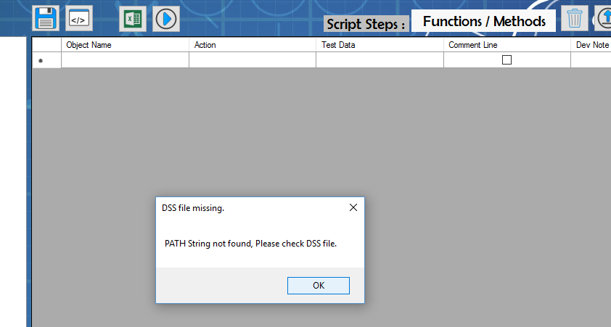

* Closed above window
* It creates the folder and file in C:\E_FrameWork\Test Componentz
* Open Path_Folder.txt file
* Copy and open the given path in the file (ex. C:\Users\spatel\AppData\Local\Apps\2.0\4QKY10AO.RY7\9PK54QPK.DBD\auto..tion_a2b5d4cffbe3b56d_0001.0000_d5eeef0d21015b44)
* Copy all the files and paste into any folder to run the exe (ex. c:\CNS_Auto)

In first time setup need to create the DSS.lib in this folder

DSS.lib file define the path of Test Components generate by automation

Ex. \\Host2\Automation\Auto-E\DB\Auto_E.mdf /* This line require even with any value */

\\Host2\Automation\Auto-E\Generated_Test_Components\ /* Initially its blank, it generates the test components as automation runs */

* Run Auto-E.exe